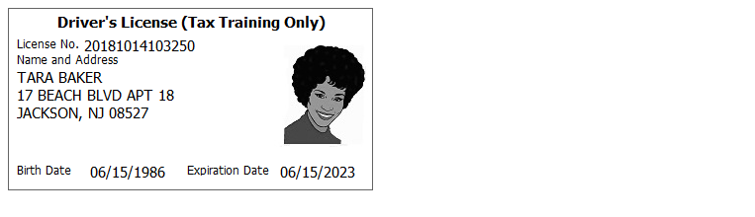

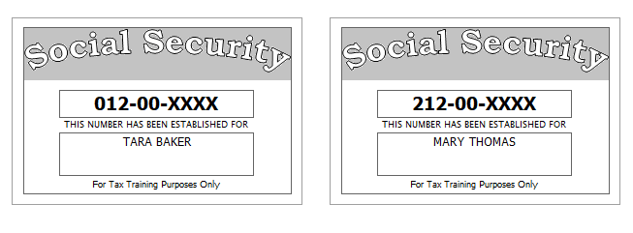

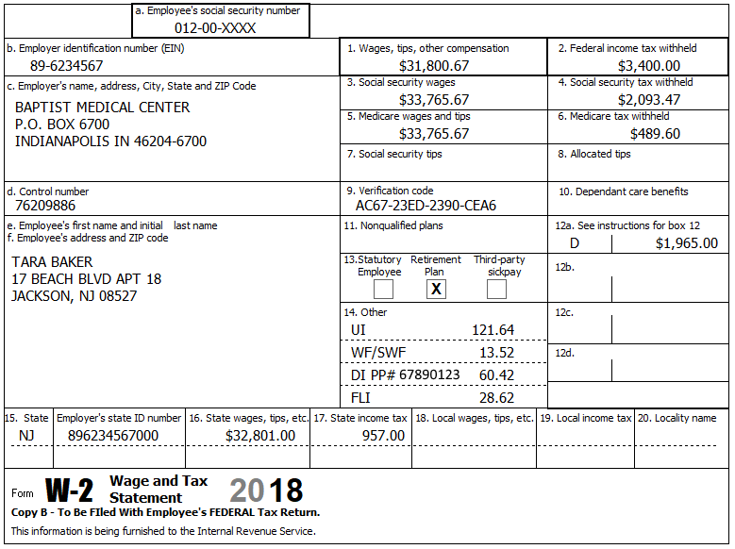

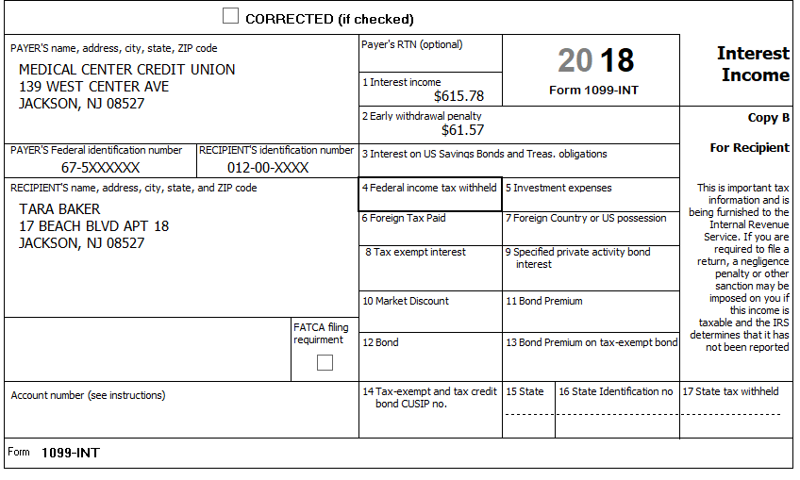

Tara was seriously injured in a car accident and became eligible for a disability pension in December of 2018. The 1099-R shows the following:

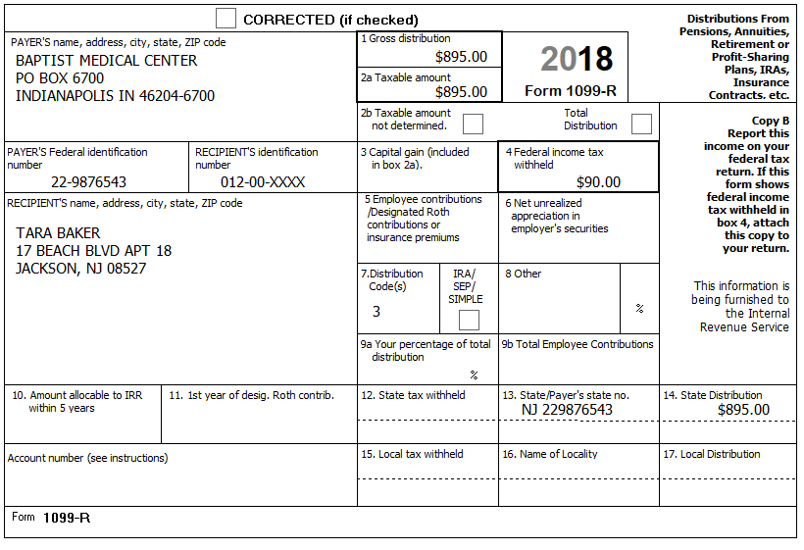

Tara was lucky one day at the Gambler’s Row Casino, winning $2,500; she has records indicating that she has $2,300 in losses.

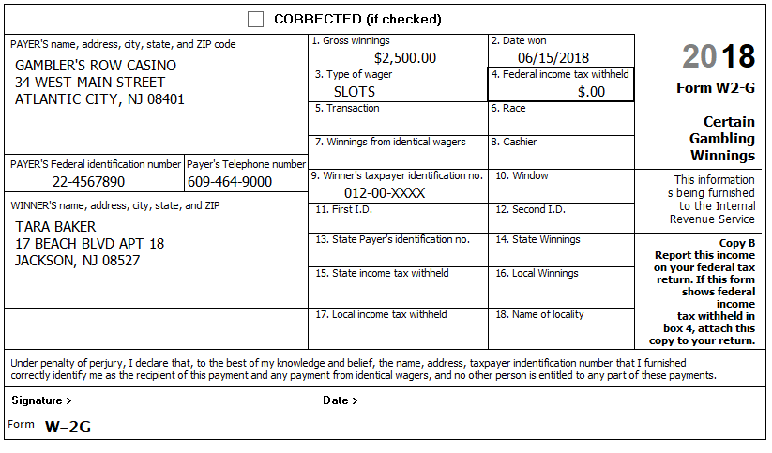

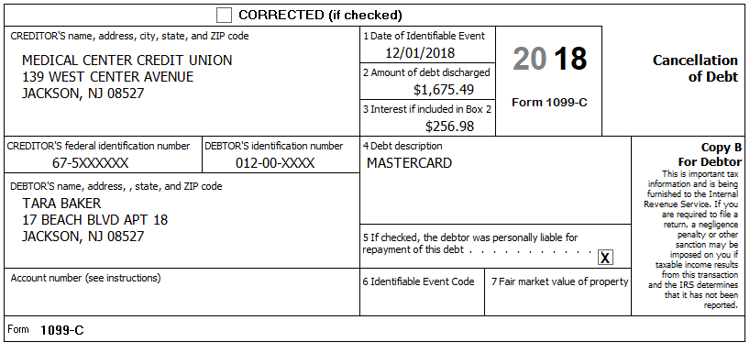

While she worked, her daughter attended the Clark County After School Program. Tara has the receipt and all pertinent information.

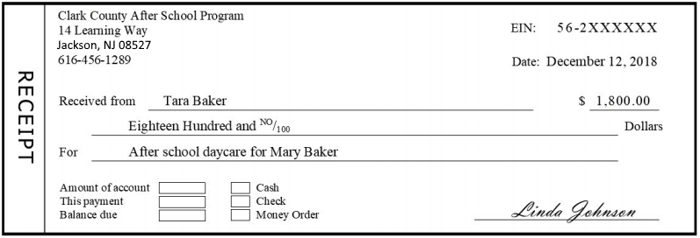

**Other Information:**

* Tara paid $400 a month for rent
* Tara was reimbursed $1000 from her employer’s FSA plan (as a distribution)
* Tara wishes to have her refund or balance due treated the same way for Federal and NJ.
* Tara does not wish to contribute to either the presidential nor gubernatorial election funds
* Last year, Tara had a balance due on her NJ return of $165 which she paid.

**Prior Year Return**

1. Tara did not bring her prior year return, so you ask a few questions:
   1. Were things pretty much the same as this year?
   2. Did you itemize?
      1. Tara says No

**ACA Supplement**

**Come back and do this after ACA training**

